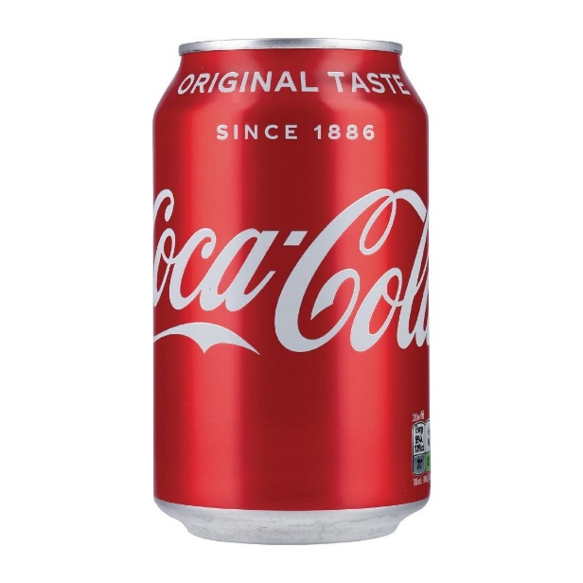 Data Curation of the Coca cola’s financial report from 2009 to 2019.

**INTRODUCTION**

The drink Coca-Cola was **originated in 1886 by an Atlanta pharmacist, John S.** **Pemberton (1831–88), at his Pemberton Chemical Company**. His bookkeeper, Frank Robinson, chose the name for the drink and penned it in the flowing script that became the Coca-Cola trademark. Though, Coca-Cola, or Coke, is a carbonated soft drink manufactured by the Coca-Cola Company. **Originally marketed as a temperance drink and intended as a patent medicine**. Since its birth at a soda fountain in downtown Atlanta, Georgia, in 1886, Coca‑Cola has been a catalyst for social interaction and inspired innovation. These unique moments in history, arranged in chronological sequence, have helped create a global brand that provides billions of moments of refreshment every day.

DATASET

However, in this project, I will be curating the data from the financial report of Coca cola between 2009 to 2019. This was set in motion by first installing the tabula-py module into my google colab.

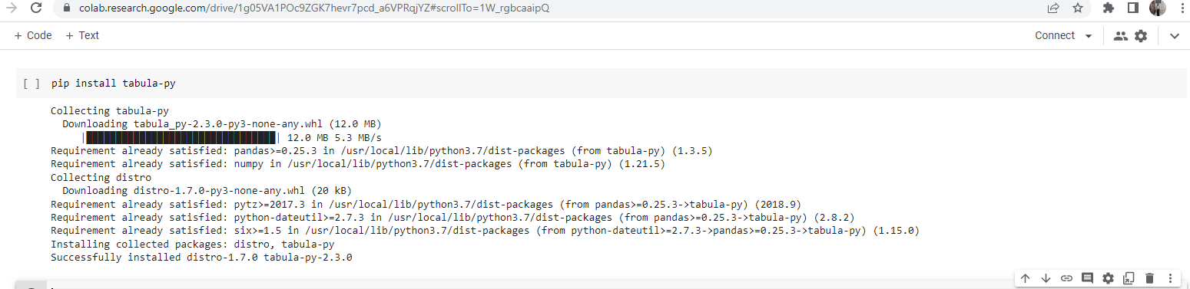

I proceeded to reading the dataset as PDF and then extracting as a CSV file using by importing tabula and pandas.

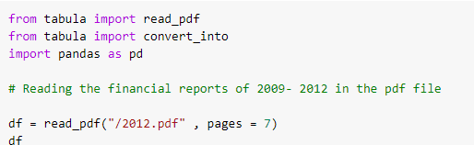 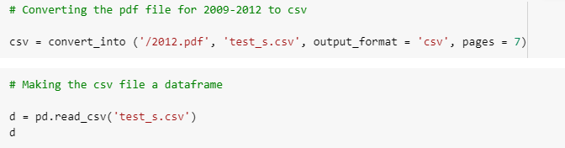

Eventually, the dataset was extracted as csv file, merged in spreadsheet and transposed to make the column attribute to be above before going ahead to read it my notebook and was then able to make a data frame of the dataset using pandas.

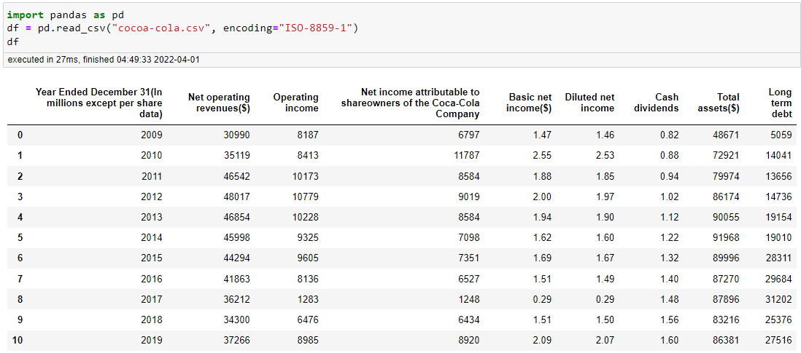

FINANCIAL STATEMENT ANALYSIS

**HIGHLIGHTS**

* Cost Of Goods Sold (COGS)
* Gross Profit Margin
* Net Profit Margin
* Return Of Assets (ROA)
* Return Of Equity (ROE)
* Debt Coverage
* Retention ratio

**COST OF GOOD SOLD (COGS)**

Cost of goods sold (COGS) refers to the direct costs of producing the goods sold by a company. This amount includes the cost of the materials and labor directly used to create the good. It excludes indirect expenses, such as distribution costs and sales force costs.

COGS = Net operating revenue - Operating Income

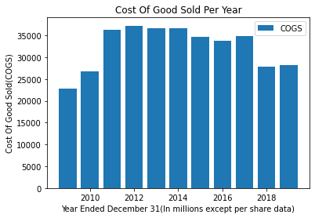

Year 2012 recorded the highest sales about 37238, followed by 2014, 36673, then 2013, 36673 while the least sale was recorded in year 2009 that is about 22803.

**GROSS PROFIT MARGIN**

The gross profit margin is a metric used to assess a firm's financial health and is equal to revenue less cost of goods sold as a percent of total revenue.

GROSS PROFIT MARGIN = (Net Operating Revenue – COGS) / Net Operating Revenue

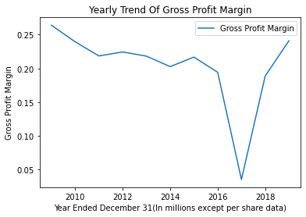

The Gross Profit Margin was at its highest in 2009(0.264182) but started dropping till it dropped to its lowest in 2017 about 0.035430, then started rising again to 0.188805 in 2018 and 0.241104 in 2019 respectively.

**NET PROFIT MARGIN**

The net profit margin, or simply net margin, measures how much net income or profit is generated as a percentage of revenue. It is the ratio of net profits to revenues for a company or business segment. Net profit margin is typically expressed as a percentage but can also be represented in decimal form. The net profit margin illustrates how much of each dollar in revenue collected by a company translates into profit.

NET PROFIT MARGIN = Operating income / Net operating revenues ($) * 100

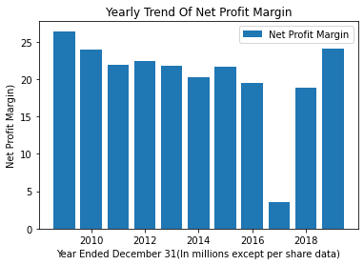

The least Net Profit Margin was recorded in 2017 (3.543024) and the highest (26.418199).

It’s of great importance to note that 2017 recorded least gross/Net Profit Margin and was unfavorably impacted as a result of the refranchising of bottling territories in North America as well as the divestitures of certain Company-owned bottling operations. In addition, net income attributable to share-owners of The Coca-Cola Company for the year ended December 31, 2017 was unfavorably impacted by a net provisional tax charge of $3,610 million recorded by the Company as a result of the U.S. Tax Cuts and Jobs Act signed into law in December 2017.

**Return Of Assets (ROA)**

The term return on assets (ROA) refers to a financial ratio that indicates how profitable a company is in relation to its total assets. ROA can be used by management, analysts, and investors to determine whether a company uses its assets efficiently to generate a profit. A ROA that rises over time indicates the company is doing well at increasing its profits with each investment dollar it spends. A falling ROA indicates the company might have over-invested in assets that have failed to produce revenue growth, a sign the company may be in some trouble. ROA can also be used to make apples-to-apples comparisons across companies in the same sector or industry.

ROA = Net operating revenues ($) / Total assets ($)

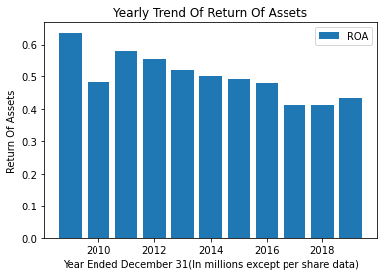

Therefore, with the above ROA, we can infer that Coca-Cola is a viable company for investment

**Return Of Equity (ROE)**

Return on equity (ROE) is a ratio that provides investors with insight into how efficiently a company (or more specifically, its management team) is handling the money that shareholders have contributed to it. In other words, it measures the profitability of a corporation in relation to stockholders’ equity. The higher the ROE, the more efficient a company's management is at generating income and growth from its equity financing.

ROE = Operating income / Net income attributable to shareowners of the Coca-Cola Company

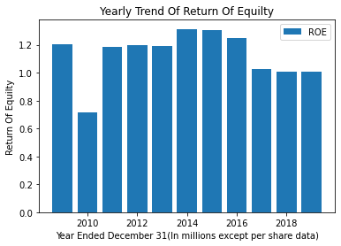

Return on equity (ROE) is an important financial metric that investors can use to determine how efficient management is at utilizing equity financing provided by shareholders. It compares the net income to the equity of the firm. The higher the number, the better. It is also important to compare the ROE of the Coca cola with others company in the same industry to be able to decide where it is profitable to invest.

**Debt Coverage**

Debt Coverage = Operating income / Long term debt

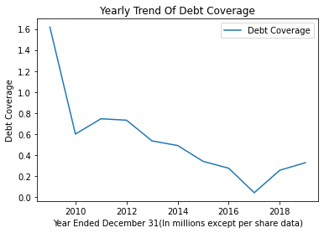

The formula for debt coverage ratio is net operating income divided by debt service. The debt coverage ratio is used to determine a company’s ability to generate enough income in its operations to cover the expense of a debt. Although, we can see that the trend of debt coverage kept reducing sporadically from 2010, least in 2017 due to the fall in operating income, then increased in 2018 and 2019.

***Basic and Diluted Net Income***

Basic and fully diluted shares are how the number of shares investors hold in a company are measured. Basic shares include the stock held by all shareholders, while fully diluted shares are the total number of shares,if the convertible securities of a company were exercised

Difference in Shares Income'] = Basic net income ($) - Diluted net income

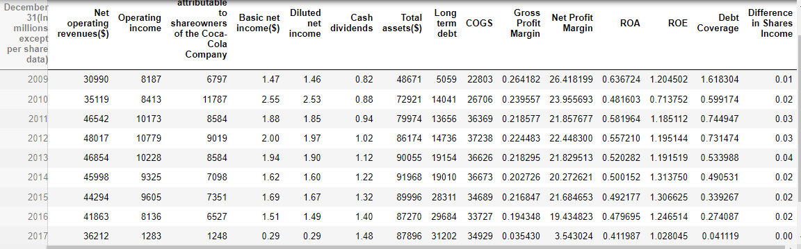

From the table, there is very minute difference between the basic net income and diluted net income, this means that the large percentage of the company's securities are convertible shares

**Retention ratio**

The retention ratio is the proportion of earnings kept back in the business as retained earnings. The retention ratio refers to the percentage of net income that is retained to grow the business, rather than being paid out as dividends. It is the opposite of the payout ratio, which measures the percentage of profit paid out to shareholders as dividends. The retention ratio is also called the plowback ratio.

Retention ratio (%) = Basic net income ($) - Cash dividends / Basic net income ($) * 100

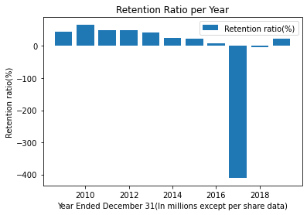

Retention ratio shows how much of Coca-Cola’s profit is paid as dividend. This company always paid dividend even in the years when they had low profits. The company experienced low profit in 2016, lowest in 2017 as well as 2018. Yet the shareholder's dividends were paid. This proves that it is a very place to invest.

In conclusion, if you are looking for where to make an investment, and for a long duration, Coca cola is a way to go because the company's dividend is arguably it’s most famous investment trait. Longtime shareholders have enjoyed decades of dividend payments that increase every year. Coca-Cola is a Dividend King that has increased its payout for 60 consecutive years, one of the longest streaks of any public company. Moreso, Coca-Cola is arguably the world's most dominant beverage company. It claims to have a 14% market share of all commercial beverage sales in developed markets and 6% in emerging markets. That may not seem like much, but this is a remarkable figure considering the vast universe of beverage products, including water, juice, tea, soda, and more.